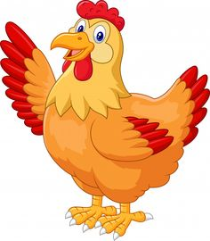**Let’s fly the coop and head toward the**

**Chicken Ranch Casino!!!**

The San Jose Buddhist Women’s Association (BWA & Auxiliary) & the Adult Buddhist Association (ABA) will be going on their “annual” casino trip on

**Saturday, May 17, 2025**

It’s been a long time since we’ve gone to the casinos. So, it’s time to get crackin’ and maybe get a nest egg in the process! This year we will try our luck at the

**Chicken Ranch Casino in Jamestown, CA**

We will be leaving at 8:00 AM in front of the SJBCB temple and returning around 5:00 PM.

**The cost is $30 for BWA/ABA members and $40 for non-members.**

This includes bus transportation, “snacks and bus activities”.

The Chicken Ranch Casino will also be giving a $10 Free Play and

a 10% discount at their restaurant “12”.

**Payments should be made to “San Jose Buddhist Church Betsuin”**

**Memo line write “BWA/ABA Casino Trip and mail to:**

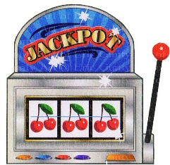

San Jose Buddhist Church Betsuin

ATTN: BWA/ABA Casino trip

640 N. 5th Street

San Jose, CA 95112

**\*\*\*Please submit payments and information no later than Monday, May 5, 2025.**

**Sign up early, once the bus is filled, that’s all we can take.**

**You will need to complete the information below and the Emergency form(s) & send with your payment. The Emergency form is required for each person who plans to go on this trip. If you are a member of both SJBWA & SJABA, please only mark “Both BWA/ABA”.**

**\*\*\*\*NOTE: Unless a replacement is found, there will be no refunds if you cancel after**

**May 5, 2025.**

Any questions - Bus trip Coordinator is Lynda Ichinaga at [lynda1naga@aol.com](mailto:lynda1naga@aol.com), 408-781-6155

--------------------------------------------------------------------------------------------------------------------------------------

**Attach this section with your check and list all names (first & last name) for which payment is enclosed for: ____________________________________________________________________**

**Total amount of payment enclosed ($30 BWA/ABA member and/or $40 non-member): ________**

**# BWA members ____ # ABA members ____ # Both BWA/ABA ____ # Non-Members ____**

**Any special bus accommodation required?**

**(If yes, please explain) _____________________________________________________**

*EMERGENCY FORM*

*(please make copies as needed)*

*(This Emergency form is* ***required for each person*** *& will be kept confidential)*

BWA member ____ ABA member ____ Both BWA/ABA ____ Non-Member ____

Name: _________________________________________________

Address: ________________________________________________

________________________________________________

Cell phone number: ____________________________________

Home phone number: ____________________________________

Email Address: ________________________________________________

***********************************************************

In case of emergency, please contact the following person:

1. This person will be on this trip with me:

Name: _____________________________________________

Relationship: ________________________________________

-- AND/OR –

1. Please contact this person (required):

Name: _____________________________________________

Relationship: ________________________________________

Home phone number: _________________________________

Cell Phone number: ­­­­­­­­­­­­­­­­­­­­­­­­___________________________________

**************************************************************

Please list all the medications that you take (If you don’t take any medications state “NONE”.

Also, note any allergies you may have.

____________________ ____________________________________________

____________________ ____________________________________________

____________________ ____________________________________________

Signature: ______________________________________________ Date: ______________________